Chapter 1 Product Introduction

1. Product description
MBSL8DI4RO module is 8-channel digital isolated input, 4-way relay isolated output, output through the RS485 interface. The module uses the standard Modbus RTU communication, adapts many kinds of software, PLC, DCS and so on. The module power supply, RS485 communication electrical signals isolated from each other, effectively inhibit the series mode and common mode interference.
- Using RS485 MODBUS RTU standard communication, configuration software, PLC and industrial touch screen can form network.
- Signal control, power supply, RS485 communication electrical signals isolated from each other.
- Communication circuit with lightning protection, anti-interference, power polarity protection.
- Communication circuit lightning protection, anti interference.
- RS485 communication signal output interface with over-voltage over-current double protection
- Signal acquisition and control can be widely used in industrial field devices.
- Communication format can be set by software.

2. Main Specifications
Project | Specifications
Signal input / output | - the input channel: 8-channel digital input  - the output channel: 4-way relay output  - the load capacity: resistive load 250V / 2A inductive load 250V / 1A  - relay coil and contact isolation voltage: 2000V
Communication output | - Communication protocol: MODBUS-RTU  - Interface type: isolated RS485 communication, the output interface with over-voltage over-current double protection  - The baud rate: 4800bps, 9600bps, 19200bps, 38400bps, 57600bps  - Parity: no parity, even parity, odd parity  - Set mode: module address, baud rate, parity can be set through the software  - Communication distance: @ 9600bps 1200 meters
Module size and installation | - Installation: standard DIN rail mounting or screw mounting  - Dimensions: 125 × 73 × 35mm
Working environment | Temperature: -10 ~ +60 ℃  Humidity: 35 ~ 85% (no condensation)
Working power | - Power supply voltage: 10V ~ 30V wide range of power supply, with power polarity protection  - Power consumption: less than 3W

3. Interface definition
Terminal name | Description | Terminal name | Description
PW+ | External power input positive terminal | 485A | RS485 signal A +
PW- | External power input negative terminal | 485B | RS485 signal B-
BDI1 | Digital input channel1 | RY1A | Relay output channel1
BDI2 | Digital input channel2 | RY1B | Relay output channel1
BDI3 | Digital input channel3 | RY2A | Relay output channel2
BDI4 | Digital input channel4 | RY2B | Relay output channel2
BDI5 | Digital input channel5 | RY3A | Relay output channel3
BDI6 | Digital input channel6 | RY3B | Relay output channel3
BDI7 | Digital input channel7 | RY4A | Relay output channel4
BDI8 | Digital input channel8 | RY4B | Relay output channel4

4. Module wiring diagram
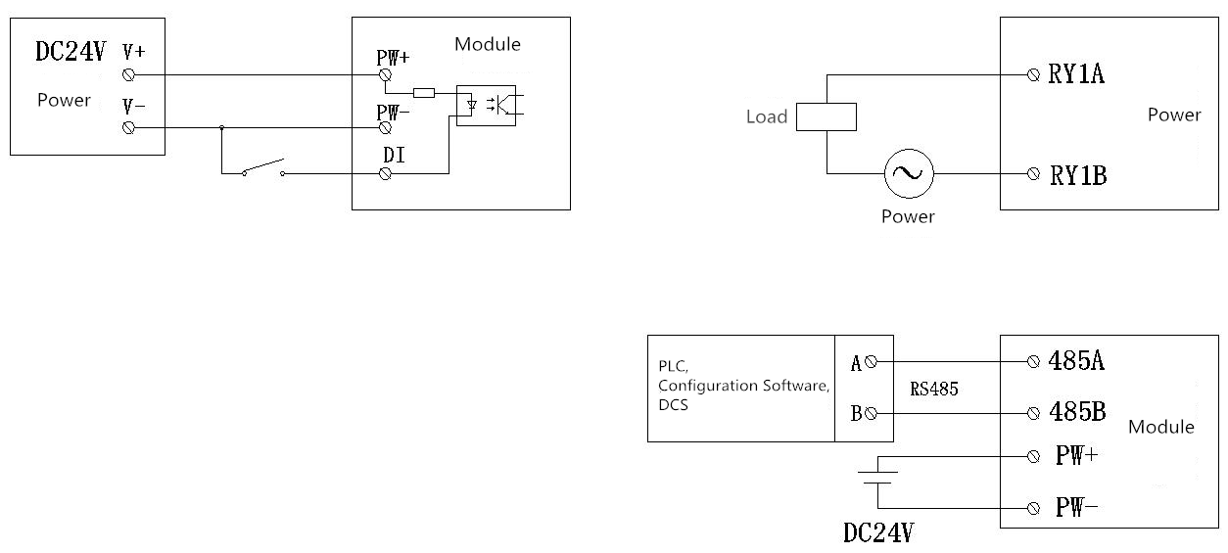

5. Communication instructions
Communication parameters (factory setting): 9600, N, 8,1
Parameter | Description
9600 | Baud rate
N (no parity) | Check digit
8 | Data bit
1 | Stop bit

Chapter 2 Modbus Register and Communication Protocol Description

1. MODBUS function code and address range

Register type | Address range | Function code | Function code description | Operating
Output coil  register | 00001-00004 | 0x01H | Read multiple coil registers | Reads the value of one or more coil registers
Output coil  register | 00001-00004 | 0x05H | Write a coil register | Write a coil register value
Output coil  register | 00001-00004 | 0x0FH | Write one or more coil registers | Write the value of one or more coil registers
Hold register | 40001-40016 | 0x 03H | Read multiple holding registers | Reads the value of one or more holding registers
Hold register | 40001-40016 | 0x 06H | Write a single holding register | Writes a data to the holding register
Hold register | 40001-40016 | 0x 10H | Write multiple holding registers | One or more data is written to the holding register
Digital input | 10001-10008 | 0x02H | Read Input Discrete | Discrete Input Register

2. Register Definition Description
(1) Output coil register (function code: 0x01H, 0x05H, 0x0FH)
Address | Parameter | Length | R / W | Min | Max | Description
00001 | DO1 | 1 | R / W | 0 | 1 | Relay output channel1
00002 | DO2 | 1 | R / W | 0 | 1 | Relay output channel2
00003 | DO3 | 1 | R / W | 0 | 1 | Relay output channel3
00004 | DO4 | 1 | R / W | 0 | 1 | Relay output channel4

(2) Holding register (function code: 0x03H, 0x06H, 0x10H)
Address | Parameter | Length | R / W | Min | Max | Description
40001 | DI（1~8） | 2 | R | 0 | 0xff | Reads the status of the 8-bit digital input
40002 | DO（1~8） | 2 | R / W | 0 | 0x0f | Controls the status of the 8-bit digital output
40003 | Device Address | 2 | R / W | 1 | 247 | 1 (default)
40004 | Baud rate | 2 | R / W | 1 | 5 | 1(4800)  2(9600) default  3(19200)  4(38400)  5(57600)
40005 | Check digit | 2 | R / W | 1 | 3 | 1 (No parity) Default  2 (Odd parity)  3 (Even parity)
40006 | Function code selection | 2 | R / W | 0 | 1 | 1 The holding register controls the output port
40007 | Product Version | 2 | R | 0 | - | Year + month + day

(3) Discrete input register (function code: 0x02H)
Address | Parameter | Length | R / W | Min | Max | Description
10001 | DI1 | 1 | R | 0 | 1 | Digital Input bit 1 status
10002 | DI2 | 1 | R | 0 | 1 | Digital Input bit 2 status
10003 | DI3 | 1 | R | 0 | 1 | Digital Input bit 3 status
10004 | DI4 | 1 | R | 0 | 1 | Digital Input bit 4 status
10005 | DI5 | 1 | R | 0 | 1 | Digital Input bit 5 status
10006 | DI6 | 1 | R | 0 | 1 | Digital Input bit 6 status
10007 | DI7 | 1 | R | 0 | 1 | Digital Input bit 7 status
10008 | DI8 | 1 | R | 0 | 1 | Digital Input bit 8 status

Chapter 3 Product Configuration

1. Communication settings
(1) Default factory-set communication parameters
Item | Register Address | Description | Default value
Address | 40003 | 1 default | 1
Baud rate | 40004 | 1(4800)  2(9600)default  3(19200)  4(38400)  5(57600) | 2
Check digit | 40005 | 1 (No parity) Default  2 (Odd parity)  3 (Even parity) | 1
Data bit | -- | Not adjustable | 8 bit
Stop bit | -- | Not adjustable | 1 bit

(2) Reset communication parameters
Press the "button" on the back of the module with a toothpick for 3 seconds or more until the "RUN" red indicator flashes. Release the button, the RUN light flashes three times, and then RUN light is always on (running state), it indicates that the factory default settings have been restored. After re-power the communication parameters are reset to default.

2. Communication Indicator Description
(1) When the module is powered on, the module red indicator "RUN" is always on. When the reset key is pressed, it will flash 3 times at 1 second intervals.
(2) In the module communication, the communication indicator flashes according to the received data "RXD", after the CPU processes, the indicator light flashes according to the transmission data "TXD". The indicator flashes abnormally when communication is abnormal.

3. Debugging instructions for the host software
This module provides a standard modbus debugging software to achieve the function of the module debugging and parameter settings, please follow the steps below:
(1) Use the RS485 converter to connect the computer and the module.
(2) Connect a 24 V external power supply to the module and power on. To avoid unnecessary damage, check whether the positive and negative terminals of the power supply are connected correctly before powering on.
(3) Open the debugging software to edit the file, set the correct communication parameters, open the communication port, enter the function debugging or parameter setting interface.
(4) Select the appropriate settings, acquisition and control options.

